**­SUPPLEMENTARY MATERIAL**

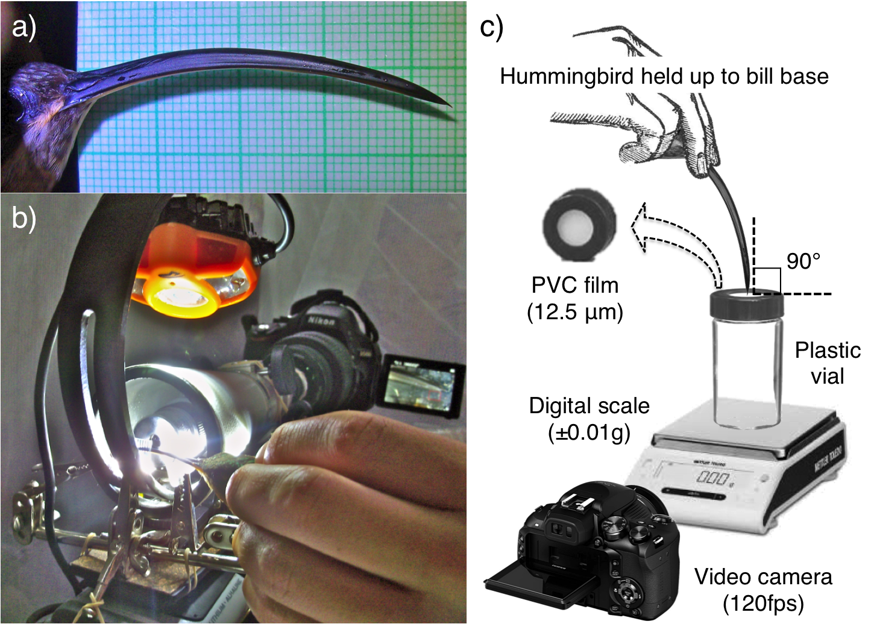

**Figure A1.** Methodologies for morphological and functional analyses. (a) Photograph of the bill of a male Long-billed hermit (*Phaethornis longirostris*) in lateral view with millimetre paper in the background. (b) Field set-up for photographing hummingbird bill tips. We coupled a digital camera (16.2 Megapixel resolution) to a field-dissecting microscope (pictures taken at 30x magnification). Note on the left one of our study subjects and, on the right, the camera LCD screen allowing real time visualization for slight adjustments to achieve the proper angle of the photograph. We triggered the camera using a remote control. (c) Experimental setup to estimate bill puncture capability. We measured the force required to puncture a Polyvinyl chloride film with different bill morphologies (see Methods: Functional assessment).



**Figure A2.** Regression between pointiness index and bill tip elongation values.Measures were taken from lateral macro photographs of male Long-billed Hermits (*F*1,65= 21.41, *R*2=0.236, *P*<0.0001).

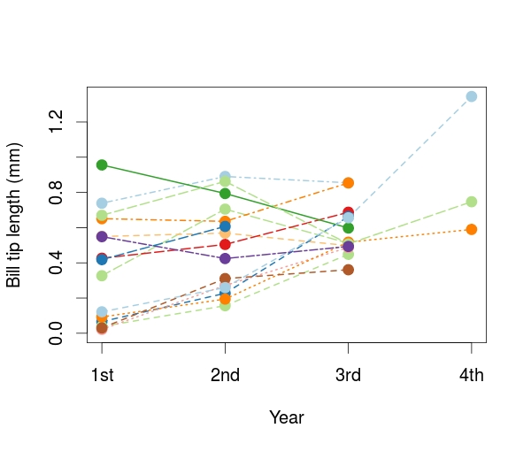

**Figure A3.** Changes in bill tip length over time in males captured during three or four consecutive years. Lines in different colours represent different individuals. Note that there is no consistent pattern besides the development of longer bill tips in juveniles that were captured for the first time with small maxillary tip elongations (~ 0.0 mm); all of these individuals grew longer bill tips in the second year.

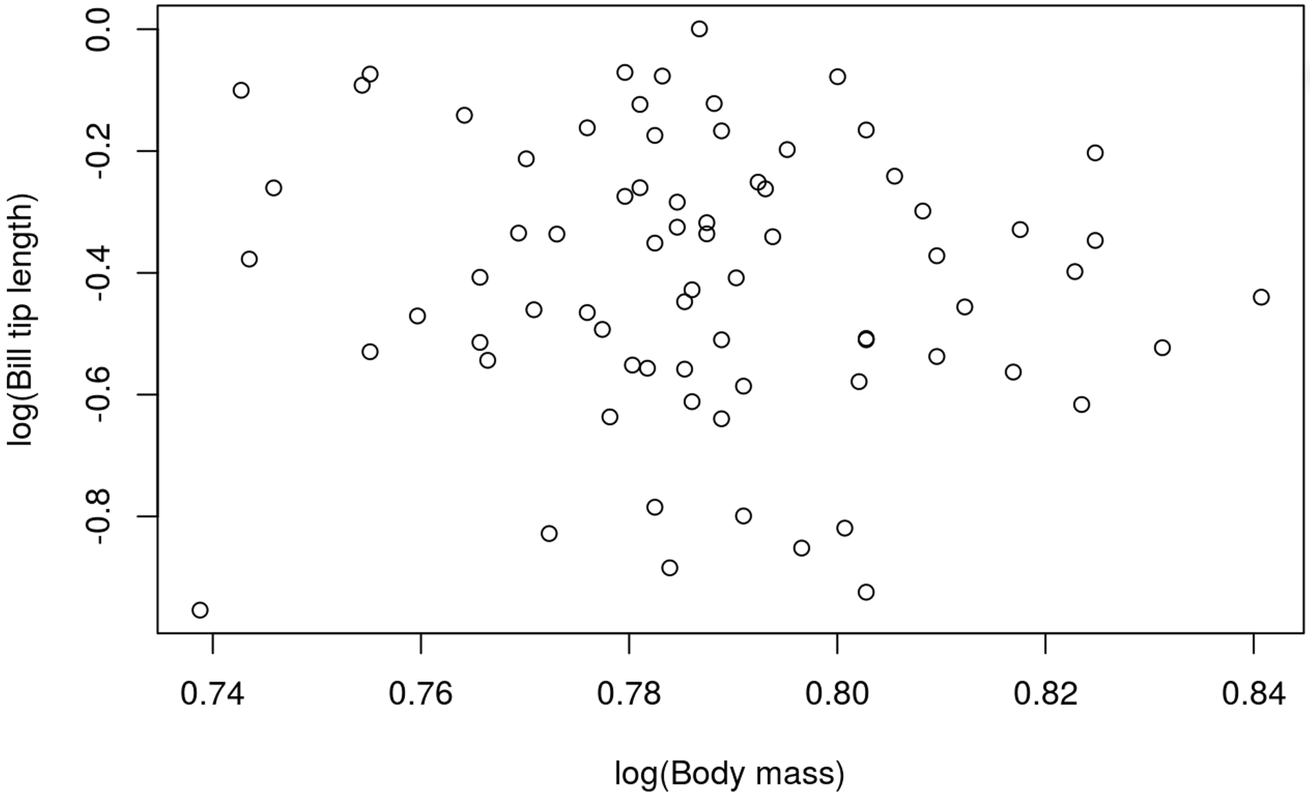

**Figure A4.** Example of allometry test for the bill tip elongation. We used the Standardised Major Axis Tests and Routines (SMATR 3 package in R), including log transformations of the data, and accounting for variance of error in the independent variable. In the shown graph, there is no correlation between the variables (*R*2=0.0079, *P* = 0.46).

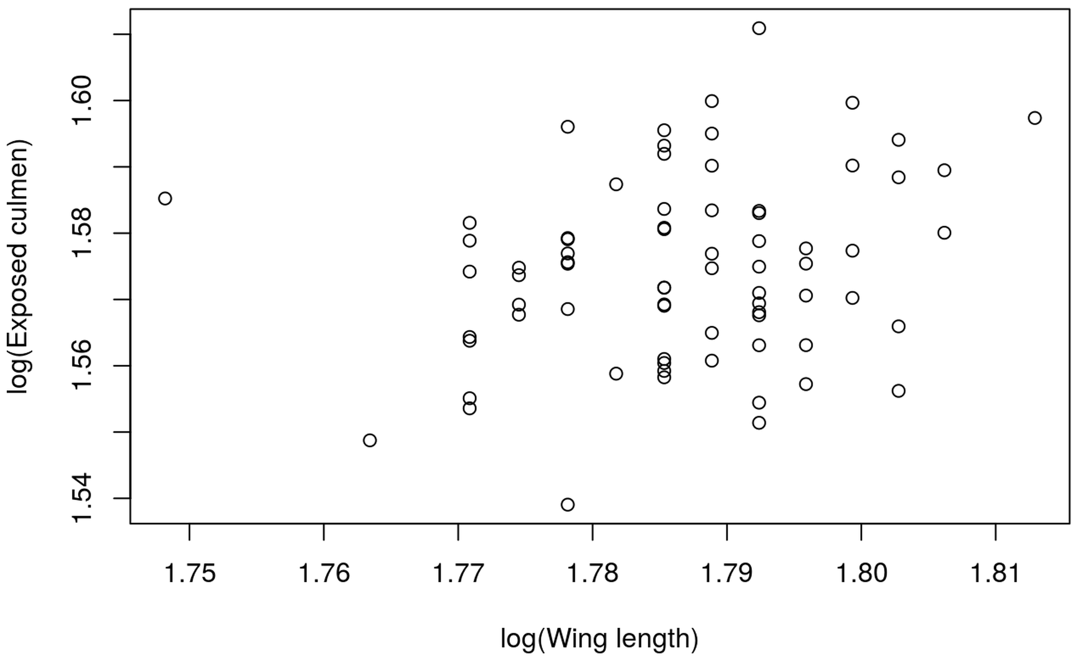

**Figure A5.** Example of allometry test for bill length using the SMATR software. We present the correlation closest to significance, in this graph the 95% confidence intervals (0.99 – 1.56) include the isometry slope of 1. However, the correlation between the variables is only marginal (*R*2=0.052, *P* = 0.053).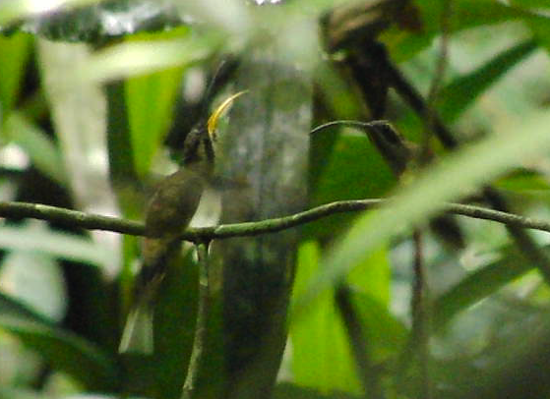

**Movie A1.** Video of Long-billed Hermits displaying. The calling male is approach by an intruder who displaces him from the branch by displaying and trying to mount him. The resulting mutual displays increase in aggressiveness, from perch exchange, side to side movements with their bills open (“float”) to upside down head bobbing and fast bill closing (“bill pop”), to stabbing attempts. Their vocalizations gradually increase in volume as the conflict escalates. Eventually the interaction ends on a chase.

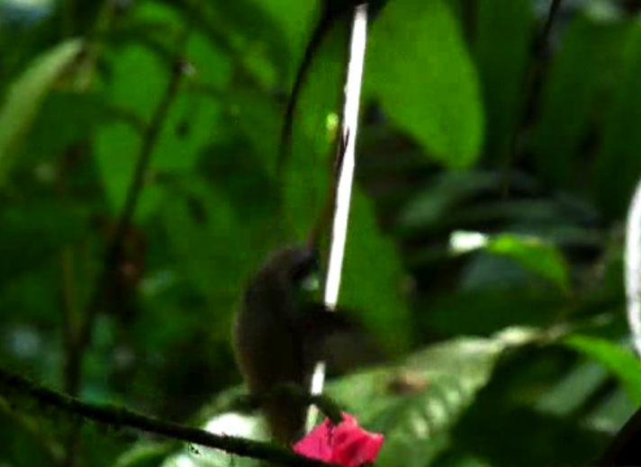

**Movie A2.** Video of male Long-billed Hermits fighting over dominance of a perch. After repeated displays (see Movie A1), the hostile interactions escalate to jousting (physical contact) if the intruder persists. The male charging from above stabs his opponent in the throat and the final chase results in the retreat of the intruder. The perch is marked with pink flagging tape and the resident male is marked with a flag is his back. Since the stabbing is swift, the clip is played in slow motion (1/8th of normal speed). Note how the usual “chirp” becomes a complex song when slowed down.

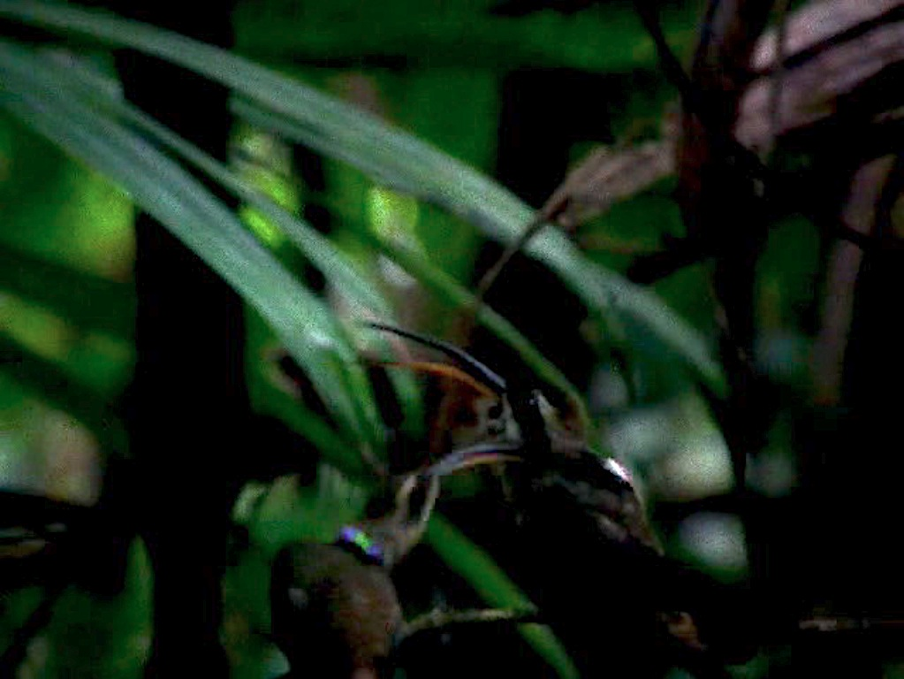

**Movie A3.** Videos of male Long-billed Hermits interacting side by side. Two sequences showing four different territorial males. One of the males in each sequence comes to an already defended perch from a territorial male. The incoming male pecks and sometimes nips at the throat of the defending male. After several pecks, which in some cases are returned (first sequence), the interaction escalates into charging and a final chase.

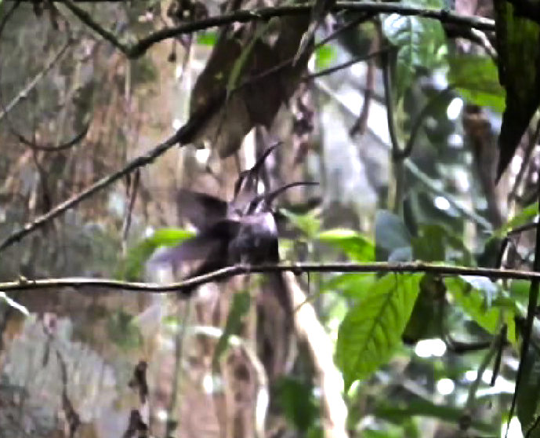

**Movie A4.** Video of Long-billed Hermit courtship and copulation. The territorial male (marked with a coloured back tag) raises and fans his tail when the female (unmarked) flies above him. While the female approaches, the male displays his gape and starts fluttering his tail excitedly. The female perches on one side and then the other, gradually moving closer until the male starts hovering and displaying in front of her. The male performs the “float” and “bill pop” displays and then proceeds to mount the female. At this point the female, who has been accelerating her wings and tail movements, pauses and holds her tail up and to the side.